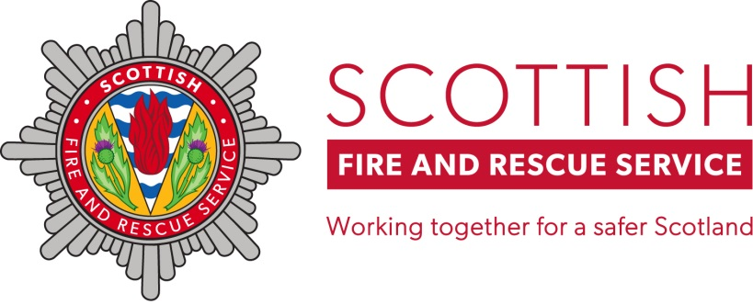

**Information Toolkit for Partner Agencies**

**SCOTTISH FIRE AND RESCUE SERVICE**

**OLDER PEOPLE**

**MONTH OF ACTION**

**MARCH 2020**

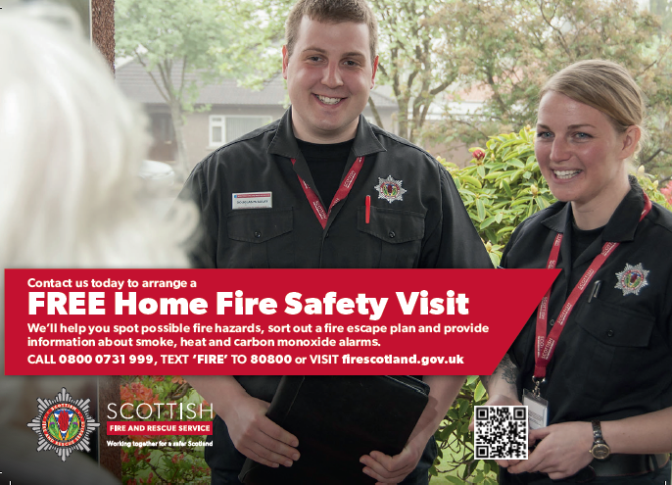

1. Introduction

Thank you for supporting the Scottish Fire and Rescue Service’s (SFRS) Older People Month of Action 2020 which seeks, through a combination of community engagement, partnership working, public relations and advertising, to reduce the levels of risk faced by older people in Scotland.

Statistics show that older people are most at risk. Over the last five years 70% of fire deaths in Scotland were people aged 50 years or over, and 27% of people injured through fire were aged 60 or over.

Scotland has an increasing elderly population demographic:

* Between mid-2005 and mid-2015 there was an 18% population increase in the 60-74 age group, compared with a decrease of 2% in the number of children under 16
* By 2035 there will be more than 1.7 million people aged 60 and over - a 31% increase on 2015
* By 2035 there will be almost 740,000 people aged 75 and over - a 68% increase on 2015

(source: http://www.healthscotland.scot/population-groups/older-people)

Our fire statistics already show the disproportionate risk older people face. It is therefore imperative that as a Service we continue to build and enhance the work we do along with partner agencies to tackle that risk.

The areas of focus for the campaign are:

* OLDER PEOPLE / HOME FIRE SAFETY VISITS
* SPECIALIST ALARMS / TELECARE
* HERE TO HELP (recognising and promoting relevant partner agencies)
* CARERS
* EMOLLIENT CREAMS
* FALLS

Within this Information Toolkit you will find an overview of the different areas of the campaign and the messages we are hoping to share. We have also included a copy of our ‘Public Relations toolkit’ which contains details of news releases and social media we are planning throughout the campaign. If you are able to share these posts your support would be most appreciated. You may also wish to follow the campaign

and share posts from our Facebook and Twitter channels which are both @SFRSYourSafety. Please also do let us know if there is anything else we should be posting / promoting during the campaign.

Of course, the need to keep older people safe from fire is an on-going priority for the SFRS and the tools and information contained within this toolkit can be used to support engagement with this group throughout the year and we will be happy to explore ways to expand and develop our partnership working.

If you would like more information regarding the campaign, objectives and key messages please contact Stephen McKee, the SFRS Prevention and Protection Directorate’s Campaigns and Engagement Officer on 01698 402259 / stephen.mckee@firescotland.gov.uk.

1. How can you help?

As an organisation that deals directly with older people, or has a network of local organisations and groups that work with this group, you can help us to share key fire safety information. This can be done by:

* Including advice and guidance on your website or more traditional outlets (e.g. posters, leaflets)
* Follow our Facebook and Twitter pages @SFRSYourSafety
* Share our messages via social media
* Include information in newsletters and magazines

There may also be an opportunity for professional care staff who support those living independently in the community to receive fire risk awareness training from the SFRS.

As well as communicating directly with older people, we also need to get our messages out to those who support them. This maybe formal and informal carers, and practitioners providing services. Through your support you can help to:

* Raise awareness amongst staff members
* Identify someone who may be at risk from fire and refer them for a free Home Fire Safety Visit

Tools to support all the above are contained in this pack. These include:

* Social media messages and links
* Facts and figures
* Fire safety advice
* Your Guide to Fire Safety (attached leaflet)
* LearnPro Risk Recognition eLearning module

1. Facts and figures

**Causes**

Most fire fatalities are caused by smokers’ materials. This includes dropped cigarettes and unsafe disposal of smouldering cigarettes, tobacco or matches.

Most fires in the home are caused by forgetfulness or distraction while cooking.

A lack of concentration, forgetfulness or cognitive impairment (which may be due to dementia) are the most serious risk factors for accidental fires, fire casualties and fatalities in the home.

Other causes include electrical appliances, candles, portable heaters, washing machines, electric blankets and mobile phone chargers.

**Fire Fatalities**

27% of people injured through fire in Scotland were aged 60 years and over during the last five years.

70% of fire deaths in Scotland were people aged 50 years or over during the last five years.

In the majority of fire fatalities involving older people a number of contributory factors are evident. These include living alone, mobility problems and health issues.

Causes

**Demographics**

Scotland has an increasing elderly population demographic, with the number of those aged 75 and over expected to rise by 68% between 2015 - 2035.

In Scotland, by 2035, there will be more than 1.7 million people aged 60 and over - a 31% increase on 2015. This equates to approximately 31% of Scotland’s population based on current population figures.

**Costs**

Average cost of a domestic fire - £44,523

Single fire fatality - £1.6m

(Economic Cost of Fire – Estimate for 2008)

1. How the Scottish Fire and Rescue Service can help

**FREE Home Fire Safety Visit**

We provide free Home Fire Safety Visits to households across Scotland. Our staff can help spot possible fire hazards, sort out a fire escape plan and provide information about smoke, heat and carbon monoxide alarms.

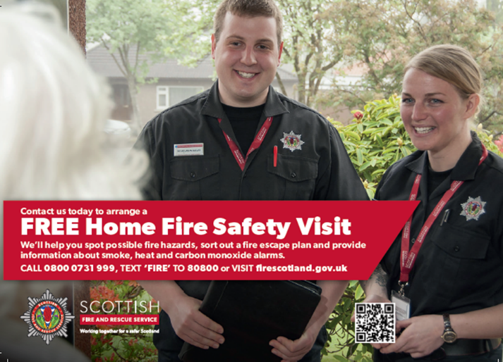A Home Fire Safety Visit only takes around 20 minutes, and that 20 minutes might just save a life.

**Visits are easy to arrange**

A Home Fire Safety Visit can be organised at

a time that suits the householder, day or night.

Contact us now:

**CALL 0800 0731 999**

**Text “FIRE” to 80800**

**or**

**visit www.firescotland.gov.uk**

**Training and advice for partner agencies**

We work with a range of partners across the country to help them identify fire risks within the home and the associated contributory factors. Our staff can provide Risk Recognition training and establish simple and effective referral processes to ensure those at risk are highlighted and can receive a Home Fire Safety Visit.

**Engage directly with older people**

We have fire stations and personnel located across the country. We are happy to come and deliver talks to a wide range of groups, whether this be at a coffee morning or visit to a day-centre or sheltered housing complex.

For more information about how we can help locally, please contact your local fire station (details are on our website <http://www.firescotland.gov.uk/your-area.aspx>) or Area Headquarters.

**Scottish Fire and Rescue Service – Local Senior Officer Area contact details (please ask for a member Prevention & Protection)**

|  |  |  |
| --- | --- | --- |
| **EAST** | **NORTH** | **WEST** |
| **Edinburgh City**  McDonald Fire Station,  McDonald Road,  Edinburgh,  EH7 4NS 0131 550 4951 | **Highland**  16 Harbour Road  Longman West  Inverness  IV1 1TB 01463 723000 | **Argyll & Bute/East & West Dunbartonshire**  2 Kilbowie Road  Clydebank  G81 6QT  01389 385999 |
| **Stirling-Clackmannanshire-Fife**  Alloa Fire Station,  Clackmannan Road,  Alloa,  FK10 4DA 01259 724112 | **Orkney, Shetland & West Isles**  4 Robertson Road, Stornoway,  HS1 2LL  01851 705051 | **East Renfrewshire / Renfrewshire & Inverclyde**  5 Thornhill  Johnstone  PA5 8JH  01505 356620 |
| **East & Mid Lothian and Scottish Borders**  Dalkeith Fire Station,  Abbey Road,  Dalkeith 0131 660 1672 | **Dundee, Angus, Perth & Kinross,**  Blackness Road  Dundee  DD1 5PA  01382 322222 | **North, South & East Ayrshire**  4 Barr Street  Ardrossan  KA22 8HD  01294 607000 |
| **Falkirk & West Lothian**  Falkirk Fire Station,  Westfield  FK2 9AH  01324 610500 | **Aberdeen City**  2 Mounthooly Way, Aberdeen,  AB24 3ER  01224 618216 | **North Lanarkshire**  Dellburn Street  Motherwell  ML1 1SE  01698 402725 |
|  | **Aberdeenshire & Moray**  Constitution Street,  Inverurie  AB51 4SQ  01467 622137 | **South Lanarkshire**  Clydesmill Community Fire Station,  Westburn Drive, Cambuslang  G72 7NA  01555 667000 |
|  |  | **Glasgow**  123 Port Dundas Road  Glasgow  G4 0ES  0141 302 3333 |
|  |  | **Dumfries & Galloway**  120-124 Brooms Road  Dumfries  DG1 2DZ  01387 734834 |

1. Partnership Working

Partnership working is an essential element of the Older People Month of Action 2020. Nationally we will work with our key partners to promote messages.

Our Local Senior Officer (LSO) Areas also work with local partners who can support the Month of Action. This support may involve shared activities or events.

Where agencies can assist in making referrals for older people who would benefit from a Home Fire Safety Visit (HFSV), it may also be beneficial for partners to access the LearnPro Risk Recognition eLearning module. The following are details of how to access the module, which is free:

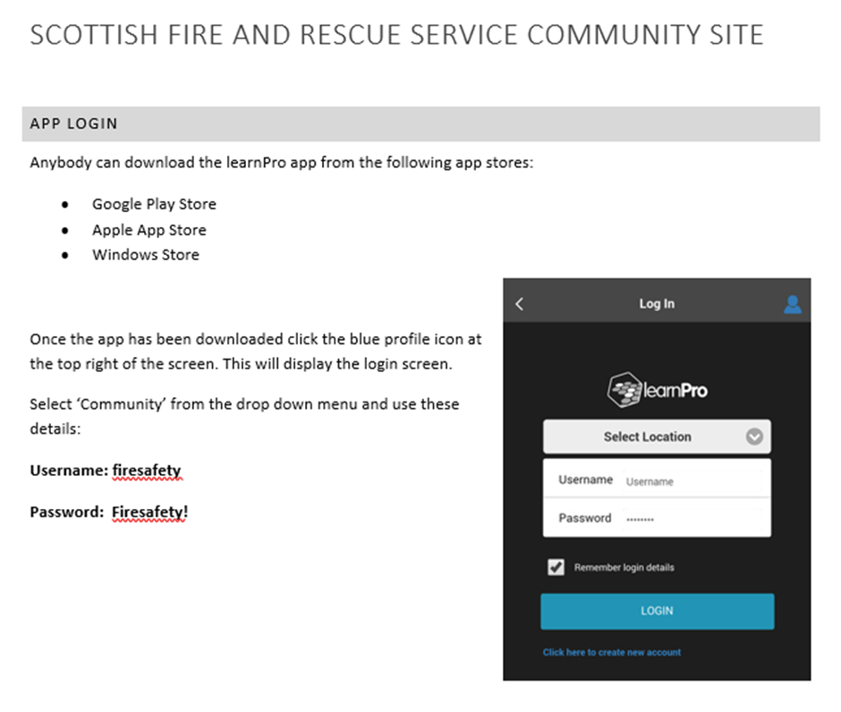

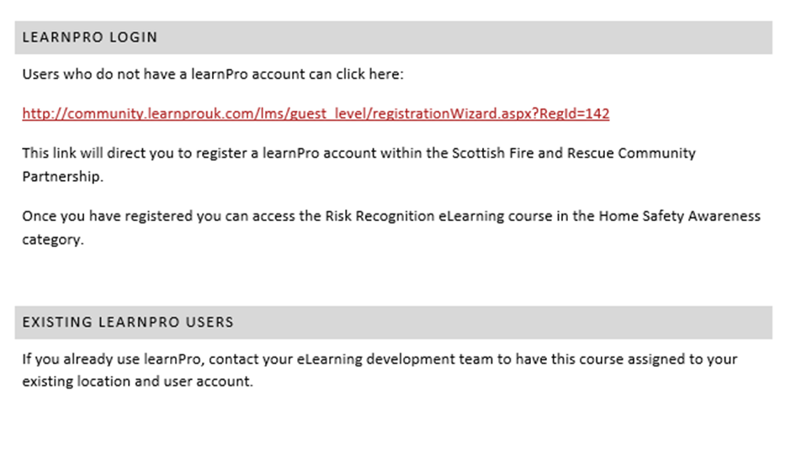

1. Schedule / Public Relations Strategy

The Older People Month of Action themes will be relevant throughout the month. However, in terms of scheduling for social media and public relations, the following timetable will apply:

PHASE 1: Saturday 29 February – Sunday 08 March

**OLDER PEOPLE / HOME FIRE SAFETY VISITS**

**SPECIALIST ALARMS**

**HERE TO HELP**

PHASE 2: Monday 09 March – Sunday 15 March

**CARERS**

PHASE 3: Monday 16 March – Sunday 22 March

**EMOLLIENT CREAMS**

PHASE 4: Monday 23 March – Sunday 29 March

**FALLS**

The campaign offers the opportunity to gain media support at a local and national level. Coverage via press, radio, web, social media and other outlets, including via local partner agencies, can greatly assist in promoting HFSVs and key messages.

A separate **Public Relations Toolkit** (to be utilised by SFRS) has been provided which covers each phase of the campaign and includes:

* A national campaign news release
* A template version of the news release with the opportunity to insert a local spokesperson
* Social media posts
* Campaign materials

If you would like more information regarding the campaign, objectives and key messages please contact Stephen McKee, the Prevention and Protection Directorate’s Campaigns and Engagement Officer on 01698 402259.

1. PHASE 1 – OLDER PEOPLE / HOME FIRE SAFETY VISITS

**Saturday 29 February – Sunday 08 March**

**OLDER PEOPLE / HOME FIRE SAFETY VISITS**

Over the last five years 70% of fire deaths in Scotland were people aged 50 years or over, and 27% of people injured through fire were aged 60 or over. The SFRS are keen to ensure every older person in Scotland is offered a free HFSV. The overarching aim of this campaign is to reduce the risks faced by older people. This phase of the campaign will be supported by advertising featuring the birthday cake image:

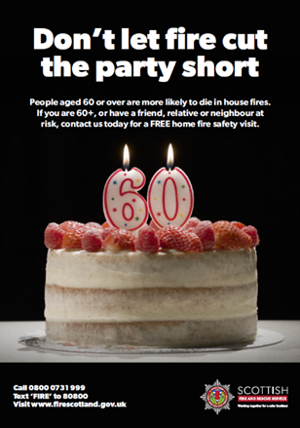

**SPECIALIST ALARMS**

Telecare is a home safety and security system that allows residents to live independently, and provides the means of summoning assistance in times of need. This element of the campaign aims to promote information regarding these systems which can substantially reduce the risks faced by older people.

**HERE TO HELP**

This part of the campaign is social media based only and seeks to highlight partners who can provide information or support for older people. Partners featured include:

* The Silver Line
* Care Information Scotland
* Age Scotland

1. PHASE 2 - CARERS

**Monday 09 March – Sunday 15 March**

There are 759,000 adult carers in Scotland and an estimated 29,000 young carers (under 16) who currently devote their lives as carers to help those who could be most vulnerable to live more safely. As part of the SFRS Older People Month of Action, SFRS are focussing on helping those carers in Scotland. This phase of the campaign is intended to reach:

* Carers who help a family member or friend live more safely
* Professional care staff who support those living independently in the community

Over the past year the SFRS has launched a pilot initiative working with care providers such as Bon Accord Care in Aberdeen and SCRT Homecare in Stirling & Clackmannanshire. Our staff have delivered fire risk awareness training to Support Workers to assist them in identifying risks within the homes of those they visit. This has already resulted in hundreds of HFSVs for people identified as being high risk of having a fire in their home. During a visit the SFRS will put measures in place to reduce or eliminate risks. LSO Areas may consider rolling out this initiative to local professional care providers.

1. PHASE 3 – EMOLLIENT CREAMS

**Monday 16 March – Sunday 22 March**

A recent report from the National Fire Chief’s Council (NFCC) estimated that “1 in 5 children and 1 in 12 adults suffer from eczema at some point in their lives and 2-3% of the population suffer from psoriasis.” One of the most effective and commonly prescribed treatments for these conditions is the regular application of emollient skin care products. Additionally, many people use emollients for the treatment of bed sores and other sores which develop as a result of restricted mobility or immobility.

Most emollients contain some level of paraffin. When creams which contain paraffin soak into fabrics such as clothing, dressings and bedding, and an ignition source is introduced, a fire is likely to occur and will burn more rapidly and hotter than it would if the fabric had not been contaminated, leaving very little time to react.

Statistics provided by the National Fire Chief’s Council (NFCC) show that since 2010 in the UK, more than 50 people have died, two sustained serious injuries and nine have been evacuated1 from a residential care home, in incidents where fabric, which has been contaminated with emollient, has been ignited by a flame or other ignition source and has burnt rapidly and intensely.

In addition, current data, gathered from fire and rescue services and the MHRA2 shows

there have been 58 cases identified (56 fatalities and two serious injuries). Actual figures are likely to be significantly higher, but emollients are not currently identified on the national Incident Reporting System. Of the 58 cases, 46(79%) people were identified as smokers, eight were non-smokers and four people were smoking status unknown. 39(67%) people had restricted or significantly limiting mobility issues and/or a care plan in place. All were aged 60 and over.

This phase of the campaign is intended to highlight these risks and to provide positive solutions.

10. PHASE 4 – FALLS

**Monday 23 March – Sunday 29 March**

Around one third of people aged 65 and over fall at least once a year. Over the age of 80, approximately one half of people fall each year. A fall can be the first sign of a new or worsening underlying health problem. It can also contribute to a decrease in mobility and consequently an increased risk to the individual if a fire occurs.

During this phase of the campaign we aim to highlight key issues around falls and reach people who have experienced a fall recently, or are concerned about a friend, relative or neighbour. As well as promoting messages via social media we are keen to arrange a free Home Fire Safety Visit for those affected by falls.

**11. Fire Safety Advice**

Partner organisations may want to include some fire safety information and advice on their websites, or share directly with the people they work with. Here is some useful information:

**Managing the risk of fire**

* You cannot remove the risk of fire completely, so make a fire plan and check that you have adequate insurance against fire. If your health deteriorates you should update your fire plan. SFRS can help you with this.

**Cooking:**

* Use the safest simplest forms of cooking. The riskiest ways of cooking are deep frying, grilling and gas hobs.
* Never fry or cook hot food when under the influence of alcohol, drugs or medication which affect your concentration or make you tired or drowsy.

**Electrical safety**

* Any damaged, faulty or unsafe electrical equipment should be repaired or replaced. Your local Care and Repair may be able to give advice or you can get information about electrical safety from the Electrical Safety First at [www.electricalsafetyfirst.org.uk](http://www.electricalsafetyfirst.org.uk) or by calling 0203 463 5100.
* Never overload plugs or sockets. Only use multi-socket adaptors which have overload protection.
* If you are concerned about the cost of repairing or replacing electrical items, call the Age Scotland Helpline to find out if you could be entitled to help from the Scottish Welfare Fund. There may also be a charity which could help you.

**Safe storage**

* Do not store things which could easily catch fire (such as aerosol sprays or pressurised containers) near to a heat source or close to your electric meter or fuse box particularly if this is in an under-stair cupboard.

**Furniture and bedding**

* Upholstered furniture must be labelled as match and fire resistant.
* Fire resistant bedding and mattresses are readily available – ask the Fire and Rescue Service for advice about this.

**In case of a power cut**

* Keep a torch and spare batteries handy.
* Avoid the use of candles or tea lights.

**Using Portable Heaters**

* Keep heaters away from curtains and furniture and never use them for drying clothes.
* Unplug or switch off portable heaters when you go out or go to bed.
* Secure portable heaters in position to avoid the risk of them being knocked over.
* Fit a Carbon Monoxide detector in all rooms containing gas or paraffin heaters.

**Open fires and chimney safety**

* If you have an open fire make sure you have a secure fire guard.
* Your chimney should be swept at least once a year.

**Make sure your home has working smoke and heat alarms**

* In the event of fire, a smoke or heat alarm will alert you and give you time to react safely and sensibly. Make sure you have working smoke alarms and consider fitting a heat alarm in your kitchen.

**How many smoke and heat alarms should I have and where should they be within my home?**

* Everyone’s home is different, so it is best to get a visit from the Scottish Fire and Rescue Service for advice, but generally:
* You should have smoke alarms in the hallway or stairway on each level, in the living room and also in your bedroom if you need to spend a lot of time in bed or have difficulty getting out of bed.
* For early detection of cooking fires you should fit a heat alarm, or a smoke alarm specifically designed for use in kitchens. This should be on the kitchen ceiling. Heat detectors are specifically designed to avoid false alarms from cooking fumes but will quickly react to a temperature increase due to a developing fire.
* Details of the revised Scottish standard for fire and smoke alarms can be found on our website

<https://www.firescotland.gov.uk/your-safety/for-householders/fire-and-smoke-alarms-in-scottish-homes.aspx>

**To test and maintain alarms**

* Once a week, press the button on the alarm to make sure that it still sounds (this should be the very loud continuous bleep which would sound if there was a fire). If you cannot reach the alarm yourself, ask a carer or family member to help.
* Dust and/or vacuum the outer casing regularly.

**If you think there is a Fire**

* Never ignore noise from a smoke or heat alarm -
* Immediately look for the possible cause and any signs of fire or smoke
* If you think there is a fire, dial 999 for the Fire and Rescue Service
* Leave your home immediately and alert people who live nearby

**(Additional information, including a fire safety checklist and night time routine can be found in the attached leaflet – Your Guide to Fire Safety)**